EXPERIMENT – 6
IN & BETWEEN
- List the type of the courses “Statistics” and “Programming”
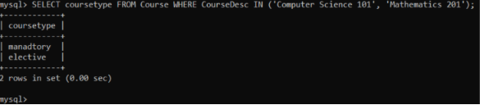

- The instructor wants to know the Course No whose scores are in the range 50 to 80

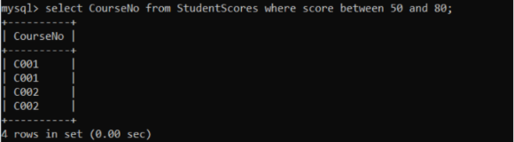

AGGREGATE
1. Find the average mark of “C002”
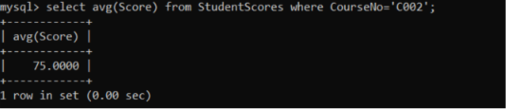
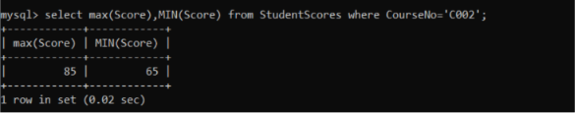
- List the maximum, minimum mark for “C002”

3. List the maximum, minimum, average mark for each course
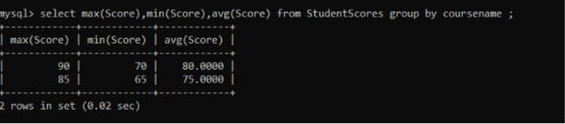
4. List the name of the courses and average mark of each course.

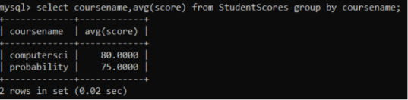
5. Calculate the sum of all the scores.

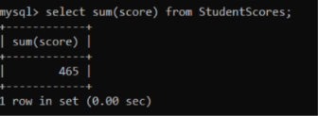
6. How many students are registered for each course? Display the course description and the number of students registered in each course.
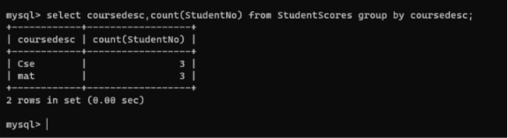

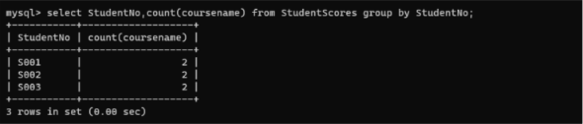
7. How many courses did each student register for?

